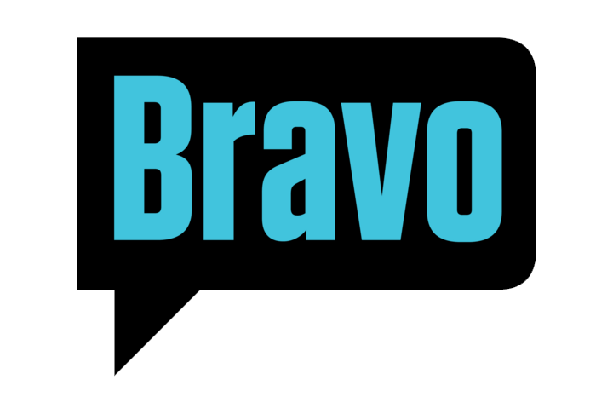

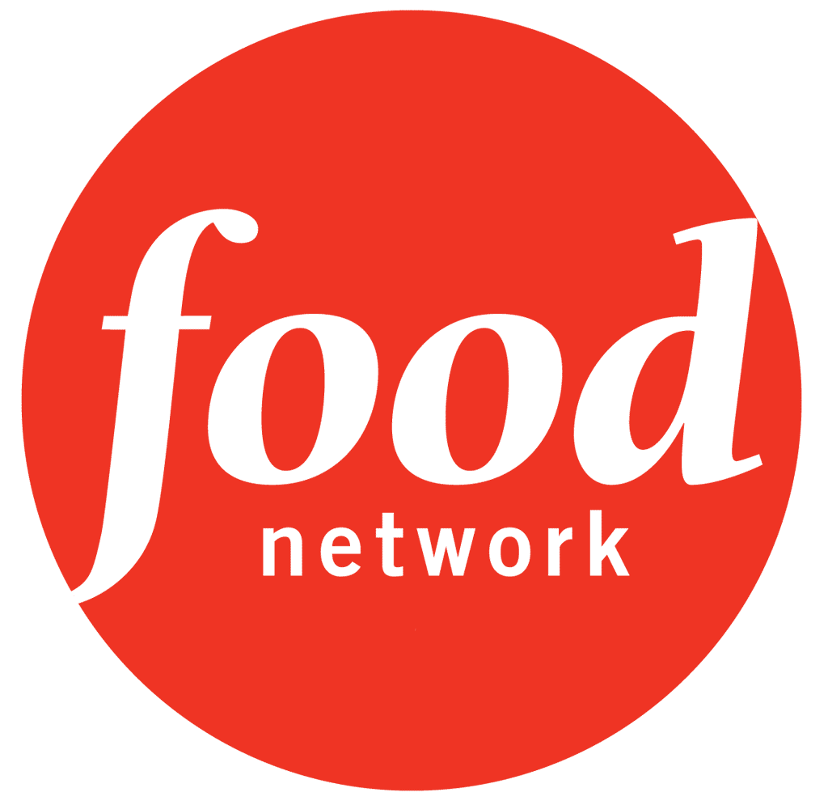
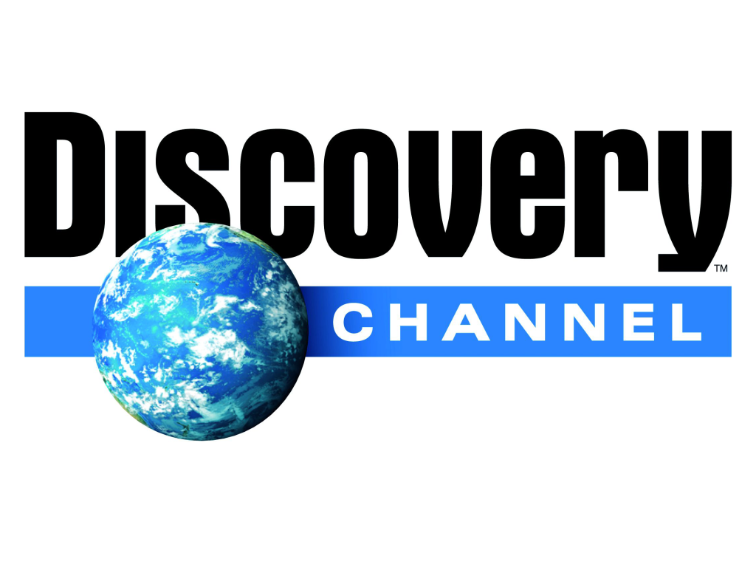






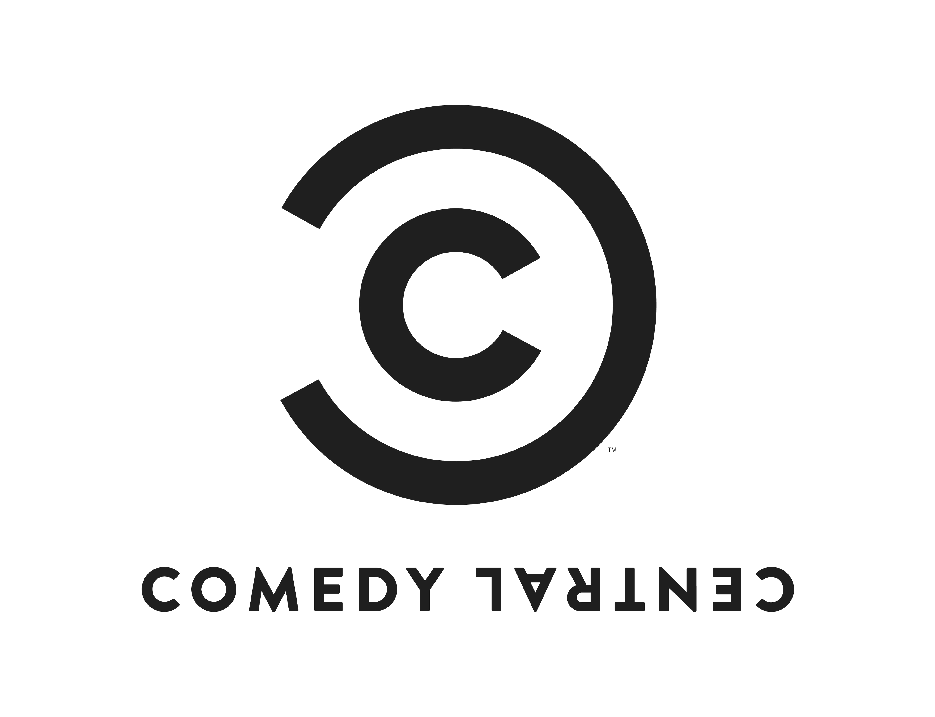








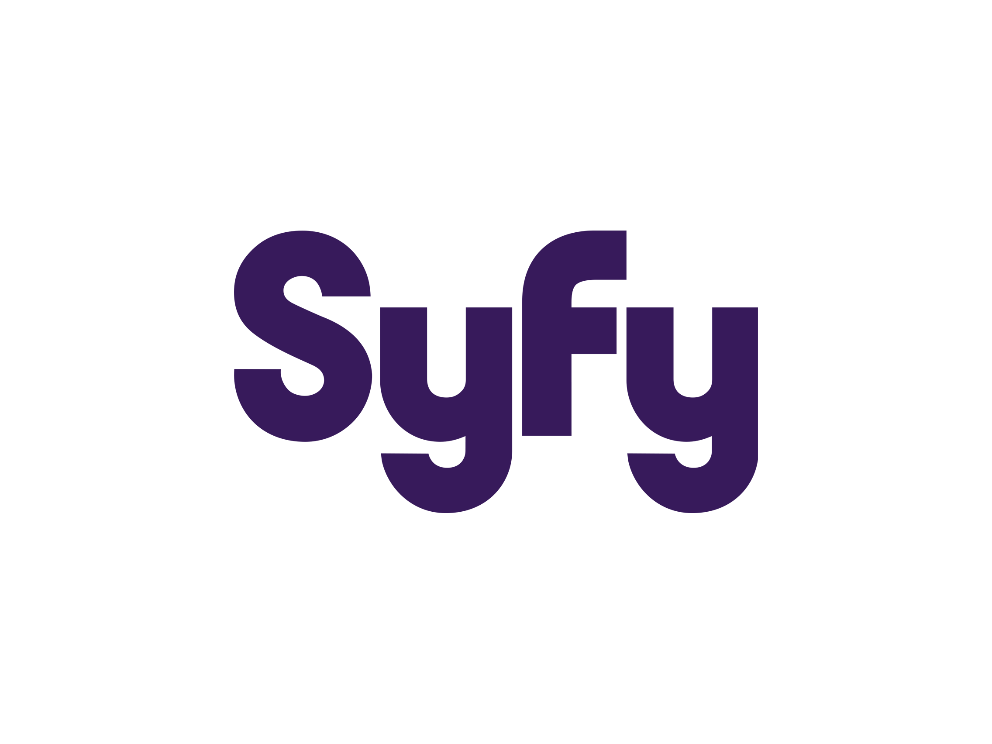






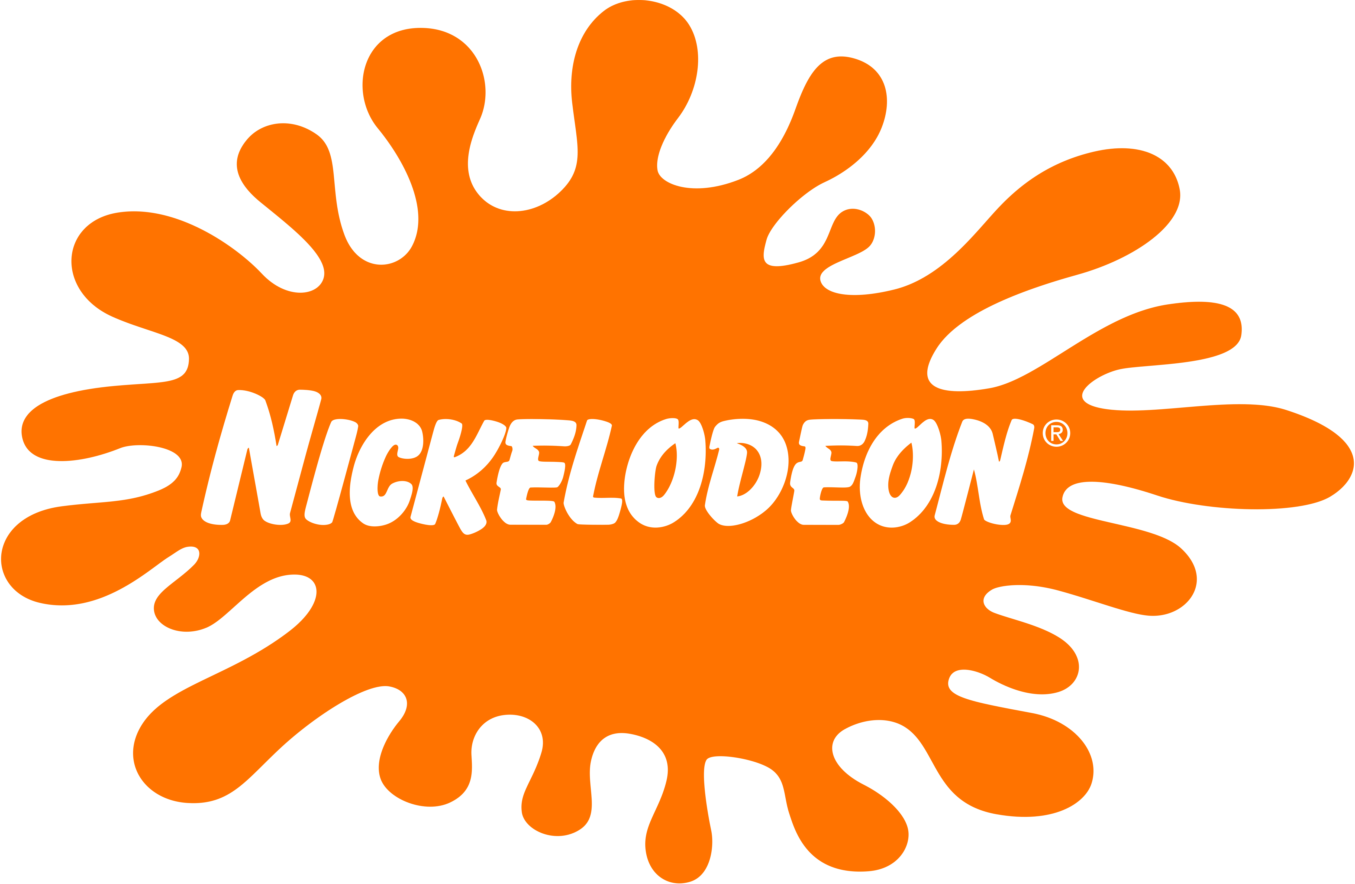

A&E - ntervention In-Depth: Flakka’s $5 Insanity,
Alaska PD

ABC - 20/20

Animal Planet – Call of The Wild man
North Woods Law
Rattlesnake Republic

BET – Black Carpet
106th and Park
50 Central
On Air Promos

Bravo - Housewives of Atlanta Reunion

Comedy Central – Comedy Central Roast Top 100

CBS Sports - NCAA segments
CBS Sports Emmy reels

Discovery - Doctor G Medical Examiner
Skeleton Stories
Mystery Diagnosis
Fatal Encounters:Sean Bell
Back Yard Oil Barons
Disappeared

DIY -The Vanilla Ice Project

E! - True Life:The History of Reality TV

Food Network – Chopped
Sweet Genius
Bake It Til You Make it

HGTV – Tough as Nails
The Vanilla Ice Project
Hawaii Life
Caribbean Life
One Week To Sell

History Channel - Pawn Stars
IFC – Quirky

Lifetime- Kosher Soul

MTV –My Super Sweet 16, Made, Engaged & Underage, Teen Cribs, Room Raiders, MC Battle 2, Real world/Road Rules Theater, Extreme Rock, Rock Rundown, All things Rock, DFX Weekend, When I was 17, Joking Off, Brothers Green, Floribama Shore Reunion, Jersey Shore Reunion

NBC Sports – NBC SportsTalk, NBC Sports On Demand, NBC Pro Football Talk
Nickelodeon - On Air Promos

Oxygen – Boss Nails

Style Network- Style Court

Sundance TV – Quirky

Syfy- Bazzillion Dollar Club, The Internet Ruined My Life.

TLC - A Baby Story, LA Ink, What Not to Wear, Help Wanted, Make Room for Multiples, Say Yes To The Dress Bridesmaids, Sister-wives Reunion Show, 90 Day Fiancé Reunion Show, Say Yes SOS

Tubi - Always Lady London

WE TV – A Stand Up Mother, Jimmy and Chrissy:Vow or Never, Life After Lock Up

Weather Channel - It Could Happen Tomorrow

VH1 - 50 Funniest Moments in Music, Vh1 Goes Inside, 100 Greatest Women in Music, Love & Hip Hop Dirty Little Secrets, Love & Hip Hop Atlanta
Youtube - BlerdLines ,The Great Untold

